March 28th, 2023

Good day EMHA Members,
I hope all is well and congratulations to all the teams this year. There has been some great write up’s of the teams seasons as well as some great successes. We also have a couple of U18 Team’s heading to the OMHA Finals to compete for the championships! Good Luck!
I am writing this email with some unfortunate news. EMHA has been made aware by the Township of Springwater that they have decided to significantly increase the rates for the ice usage next season. The rate increase is being applied to prime and non prime times and would significantly impact our association which is the largest user group of the arena.
We have been in talks with Ward 1 Councillor Matt Garwood regarding the matter. In our initial discussion, I explained to Mr. Garwood that the fee increase is between 16-20% based on last years fees. In comparison to user fees in 2018, there has been a 87% increase in user fees for our association. We explained that these new fees would likely result in an approximate increase of $30,000 for the following year membership, funds that our association and its members should not be subjected to considering the already high cost of the arena ice use. EMHA and its members have worked hard throughout the year, volunteering our time to fundraise for events like the Fall Fair Dance, Golf Tournament, Lottery Ticket Sales, Bottle Drives and other individual and team fundraising ventures so that hockey can be an inclusive sport to all members of this great community. We also have some fantastic local sponsors who have donated funds to assist our hockey community and offset operational costs. Our registration fees are already on the high end with the cost to use the ice as a major factor.
EMHA has explained to the township the increase in user fees would be some of the highest costs for minor hockey in the area. In addition, EMHA has filed complaints or concerns with the township over the last couple of years due to quality concerns with the ice surface and the facility. Below is a template provided to the township of the ice costs locally, taking into account that some arena’s rent the ice for the full 60 minutes but Springwater charges 60minutes of ice for 50 minutes of usage to allow for flooding. In looking at the information below it is important to note that the ice costs were confirmed a few weeks ago and may have changed slightly in some area’s. Regardless, it is important to note that Springwater has 43-58% higher fees than the sampled mean listed and is significantly higher than the 75th percentile. This is not acceptable and certainly not feasible for any user group, especially EMHA as the major user group for the arena.

Price Per Hour - Youth / Minor
 | Prime | Non-Prime
Springwater | 216.50 | 173.98
Barrie | 215.00 | 152.00
Oro | 171.00 | 130.00
Midland | 162.20 | 116.94
Orillia | 161.77 | 92.34
Wasaga | 153.00 | 112.00
Penetang | 137.39 | 85.51
Stayner | 129.08 | 115.54
Collingwood | 125.00 | 122.00
Coldwater | 110.17 | 67.05
Mean | 151.62 | 110.38
Median | 153.00 | 115.54
75th Percentile | 168.80 | 128.00
Springwater Above Mean | 43% | 58%
Springwater Above 75th Percentile | 28% | 36%

Mr. Garwood has explained that the new 2023 fees are a result of a Comprehensive Fees Study and it is the first time the municipality has undergone an in-depth review of all fees and associated costs. In reviewing the fees study, EMHA Executive identified a number of questions on how the independent contractor came up with, allocated and accounted for certain financials. We have asked the township to look into it and are awaiting a response back from their financial department.
It is important to also note that some user groups at the Elmvale Arena have decided to leave due to the cost increase and have signed contracts at other facilities. This is concerning for our organization as we have not heard yet if this will mean the loss of potential revenue for the arena will be passed on to user groups like EMHA, thus raising the fees even higher. In addition, EMHA wants to know what, if anything, the township is doing to attract or facilitate additional revenue streams for the arena rather than offloading costs onto current user groups.
Below is a table provided by the township that outlines the fee structure from 2014 to 2023. When looking through it you can see the significant increases since 2018 including the initial huge increase in 2019.
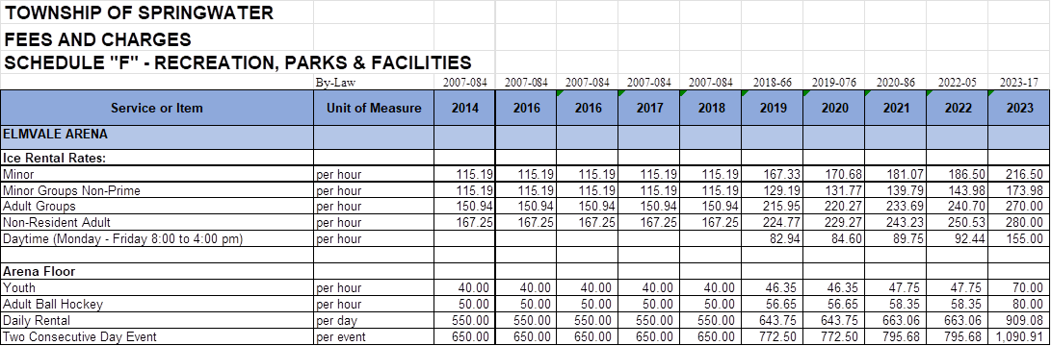

EMHA Executive will continue to work hard for its members on ensuring the costs for hockey in Elmvale remain viable. We continue to have conversations with the township regarding this unacceptable fee increase that is not sustainable in the short term nor long term for our association. We are asking that all members take the time to reach out to their elected officials in Springwater and voice your concerns on the matter.
I will do my best to keep you informed as information is available. I am also requesting that members of EMHA attend the May 4th AGM. Along with a breakdown of this past year, a review of your executive members roles and the opportunity to become a member of the executive, there will be some important discussions about this issue and others which needs to have the voice of our members heard.
Your Springwater Council Members email and telephone information can be found at:
https://www.springwater.ca/en/township-hall/mayor-and-council.aspx

If you have any questions, please do not hesitate.

Sincerely,
John Seney
EMHA President

